3. Methodology

This section firstly introduces how we obtain dataset, then how we extract features, why we use clustering, how we construct images and how we construct convolutional neural network, accordingly.

A. Dataset and Feature Extraction
To forecast price or trend for incoming days, price values can be used trivially. Price values used in this research, are retrieved from google finance [1]. Google finance provides daily stock prices with several other features and full signature of given data is date, open, high, low, close, adjusted close. In addition, they provide these features error-free i.e. adjusted in case of stock splits, dividends or rights offerings.
Financial data have high volatility because of nature of stock market. To reduce this volatility, exchange-traded fund (ETF) is used. ETFs are composition of commodity, bonds and index. Combining different type of indexes, bonds and commodities reveals the advantage of lower volatility while keeping the advantages of stock exchange. ETFs are bought and sold like regular stocks with higher liquidity and lower fees. XLF, XLU, XLI, SPY, XLP, EWG, XLB, XLK, XLV, EWH, EWC, XLY, EWW, DIA, XLE, EWA, EWJ are the most essential ETFs in The New York Stock Exchange. Hence, these stated ETFs are used in this research. After this point of paper, previously stated data will be named as raw data. Simply, raw data is a simple form of historical finance data for any given ETFs.
There are two types of methods used in finance to analyze financial data: fundamental analysis and technical analysis. On one hand, fundamental analysis is interested in statements of companies and other individuals and other general concepts which is related to stock’ itself. This analysis requires domain expertise and interpretation like human-being does. Extraction features from fundamental analysis is in different field of machine learning approached e.g. natural language processing. On the other, technical analysis is interested in features of stock e.g. close, volume without using domain expertise. Latter analysis can be interpreted as time series analysis and several time series analysis approaches can be used e.g. recurrent neural networks, long-short term memory, convolutional neural networks. In this research, we have used convolutional neural network.
To enrich dataset, several technical analysis methods are performed. We have used relative strength index(RSI), simple moving average(SMA), the moving average convergence/divergence oscillator(MACD), the Williams percent range (Williams %R), the stochastic oscillator, the ultimate oscillator, the money flow index(MFI). Descriptions and formulas for each technical analysis methods used in research, are stated in table 1.
Table.2
Feature Name | Parameters | Amount
Tanh((stationary(close))) | - | 1
volume | - | 1
RSI | 15-20-25-30 | 4
SMA | 15-20-25-30 | 4
MACD | 26,12 – 28,14- 30,16 | 3
MACD_trigger | 9,26,12- 10,28,14- 11,30,16 | 3
William %R | 14-18-22 | 3
Stochastic oscillator | 14-18-22 | 3
Ultimate oscillator | 7,14,28-8,16,22-9,18,36 | 3
MFI | 14-18-22 | 3

Todo: insert table 1. Here
Name | Desc | Formula
RSI
SMA
MACD
Williams %R
Stochastic Oscillator
Ultimate Oscillator
MFI

RSI, SMA, MACD, Williams R, Stochastic Osilatör, Ultimate Osilatör ve MFI
RSI: The RSI provides a relative evaluation of the strength of a security's recent price performance, thus making it a momentum indicator. RSI values range from 0 to 100. The default time frame for comparing up periods to down periods is 14, as in 14 trading days.
100
RSI = 100 - --------
1 + RS

RS = Average Gain / Average Loss

Where RS = Average gain of up periods during the specified time frame / Average loss of down periods during the specified time frame/
SMA: A simple moving average (SMA) is an arithmetic moving average calculated by adding the closing price of the security for a number of time periods and then dividing this total by the number of time periods.
Daily Closing Prices: 11,12,13,14,15,16,17

First day of 5-day SMA: (11 + 12 + 13 + 14 + 15) / 5 = 13

Second day of 5-day SMA: (12 + 13 + 14 + 15 + 16) / 5 = 14

Third day of 5-day SMA: (13 + 14 + 15 + 16 + 17) / 5 = 15
EMA: An exponential moving average (EMA) is a type of moving average that is similar to a simple moving average, except that more weight is given to the latest data. It's also known as the exponentially weighted moving average. This type of moving average reacts faster to recent price changes than a simple moving average.
Initial SMA: 10-period sum / 10

Multiplier: (2 / (Time periods + 1) ) = (2 / (10 + 1) ) = 0.1818 (18.18%)

EMA: {Close - EMA(previous day)} x multiplier + EMA(previous day).

MACD: the Moving Average Convergence/Divergence oscillator (MACD) is one of the simplest and most effective momentum indicators available
MACD Line: (12-day EMA - 26-day EMA)

Signal Line: 9-day EMA of MACD Line

MACD Histogram: MACD Line - Signal Line

Williams R: Williams %R, sometimes referred to as the Williams Percent Range, is a momentum indicator that measures overbought and oversold levels, comparable to a stochastic oscillator. The Williams %R is used to establish entry and exit points in the market. It compares the close of a stock to the high-low range over a period of time, typically 14 days.
The Williams %R, often shortened to simply %R, is a technical analysis oscillator. This indicator shows the present closing level of a commodity or stock in relation to the high and the low over a given number of days. This analytical tool was developed by Larry Williams, a publisher and a promoter of trading materials.
%R = (Highest High - Close)/(Highest High - Lowest Low) * -100

Lowest Low = lowest low for the look-back period
Highest High = highest high for the look-back period
%R is multiplied by -100 correct the inversion and move the decimal.
Stochastic oscillator: The stochastic oscillator is a momentum indicator comparing the closing price of a security to the range of its prices over a certain period of time. The sensitivity of the oscillator to market movements is reducible by adjusting that time period or by taking a moving average of the result.
%K = (Current Close - Lowest Low)/(Highest High - Lowest Low) * 100
%D = 3-day SMA of %K

Lowest Low = lowest low for the look-back period
Highest High = highest high for the look-back period
%K is multiplied by 100 to move the decimal point two places
Money Flow Index(MFI): The money flow index (MFI) is a momentum indicator that measures the inflow and outflow of money into a security over a specific period of time. The MFI uses a stock's price and volume to measure trading pressure. Because the MFI adds trading volume to the relative strength index (RSI), it's sometimes referred to as volume-weighted RSI.
* 1. Typical Price = (High + Low + Close)/3
* 2. Raw Money Flow = Typical Price x Volume
* 3. Money Flow Ratio = (14-period Positive Money Flow)/(14-period Negative Money Flow)
* 4. Money Flow Index = 100 - 100/(1 + Money Flow Ratio)
Ultimate Oscillator: the Ultimate Oscillator is a momentum oscillator designed to capture momentum across three different timeframes. The multiple timeframe objective seeks to avoid the pitfalls of other oscillators. Many momentum oscillatorssurge at the beginning of a strong advance and then form a bearish divergence as the advance continues. This is because they are stuck with one timeframe. The Ultimate Oscillator attempts to correct this fault by incorporating longer timefminrames into the basic formula. Williams identified a buy signal a based on a bullish divergence and a sell signal based on a bearish divergence.
BP = Close - Minimum(Low or Prior Close).

TR = Maximum(High or Prior Close) - Minimum(Low or Prior Close)

Average7 = (7-period BP Sum) / (7-period TR Sum)
Average14 = (14-period BP Sum) / (14-period TR Sum)
Average28 = (28-period BP Sum) / (28-period TR Sum)

UO = 100 x [(4 x Average7)+(2 x Average14)+Average28]/(4+2+1)

Generally, price values are consistently increasing over long period of time. More specifically, mean of price values are increasing over time. That’s why buy and hold strategy wins when compared to other sophisticated methods. This property comes with one big problem that statistical properties such as mean and variance are not applicable. To be able to use mean and variances again, these properties should be made constant over time i.e. stationarized. To make price time series stationary, first difference method is used. Simply, price values of every next day are subtracted from the day before and at the end mean around zero-point is obtained. Fig.1 shows nonstationary - and stationary price values over time.
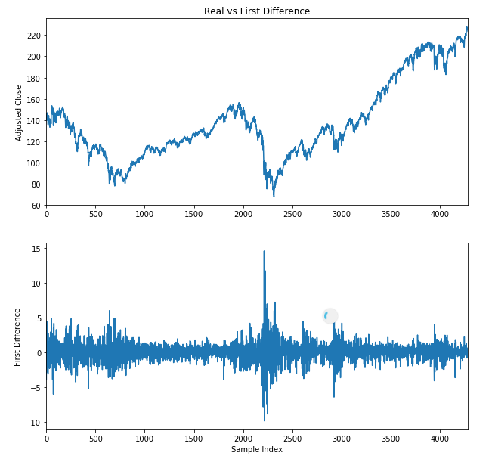
After updating new weights in models, we want to make sure that weights are in same range as it before. Therefore, stationary price values are normalized with hyperbolic tangent function (tanh) (1). Tanh function is narrowed down any given value between -1 and 1 in Fig. 2.

B. CNN
Convolutional neural network(CNN) is under a family of neural network (NN) which has several variations of multilayer perceptron. CNN consists of an input layer, several hidden layers and an output layer like any other NN does. Input layer is a representation of identity function (5). Output layer which makes decisions, passes previously calculated weights through linear function (6). The hidden layers are either convolutional, pooling, dropout or fully connected. Layers have activation functions at the end and activation functions (7,8,9), such as sigmoid, tanh, RELU, apply additional functionality e.g. normalization Weights of CNN are filters and convolve given inputs. Convolution is a process which sums the pointwise multiplications of given two functions in certain window. Pooling combines every element in certain window and outputs one result. For example, max pooling outputs the maximum element for given window. Dropout (cite here) selects several neurons, which can vote, to reduce overfitting. Fully connected layers connect every neuron in the previous layer to every neuron in the next layer. In Fig.5 CNN network provided. To update the weights of filter, An Adaptive Learning Rate Method(ADADELTA) [cite here] is used.
Input
Conv2d | 3x3 32 filter | RELU
Conv2d | 3x3 64 filter | RELU
MaxPooling | 2x2 pool size
Dropout | 0.25 dropout
Fully connected | 128 neuron | RELU
Dropout | 0.5 dropout
Output

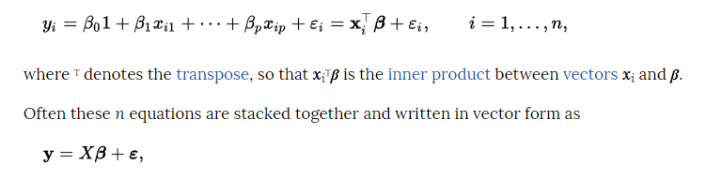
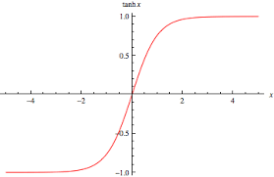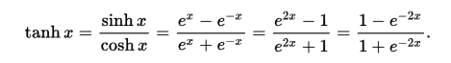

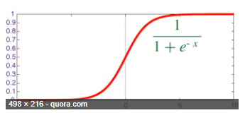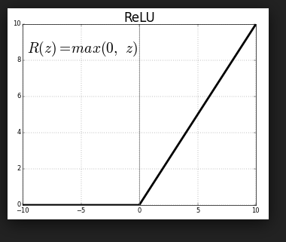
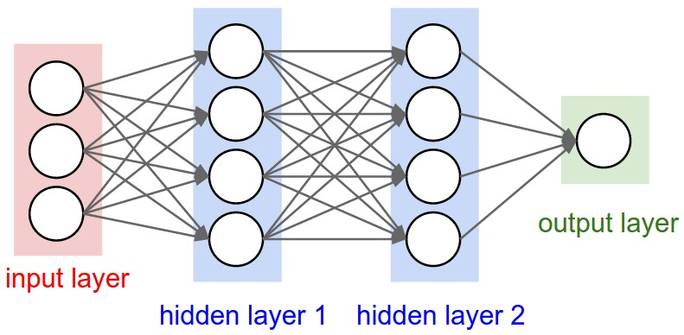

C. Clustering
2D convolution process requires locality over both x-axis and y-axis. On contrast, time series have locality over x-axis naturally, however not over y-axis. When different features are clustered together, each cluster satisfies locality in its boundary. Therefore, we examine clustering while taking each feature time series as input. Agglomerative clustering is selected because of visualization of dendrogram and bottom-up approach. Euclidean distance metric (2) is used while constructing distance matrix with Pearson correlation coefficient (3). In Fig. 4. Dendrogram of features are created.
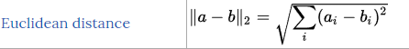(2)
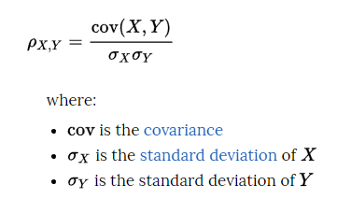(3)

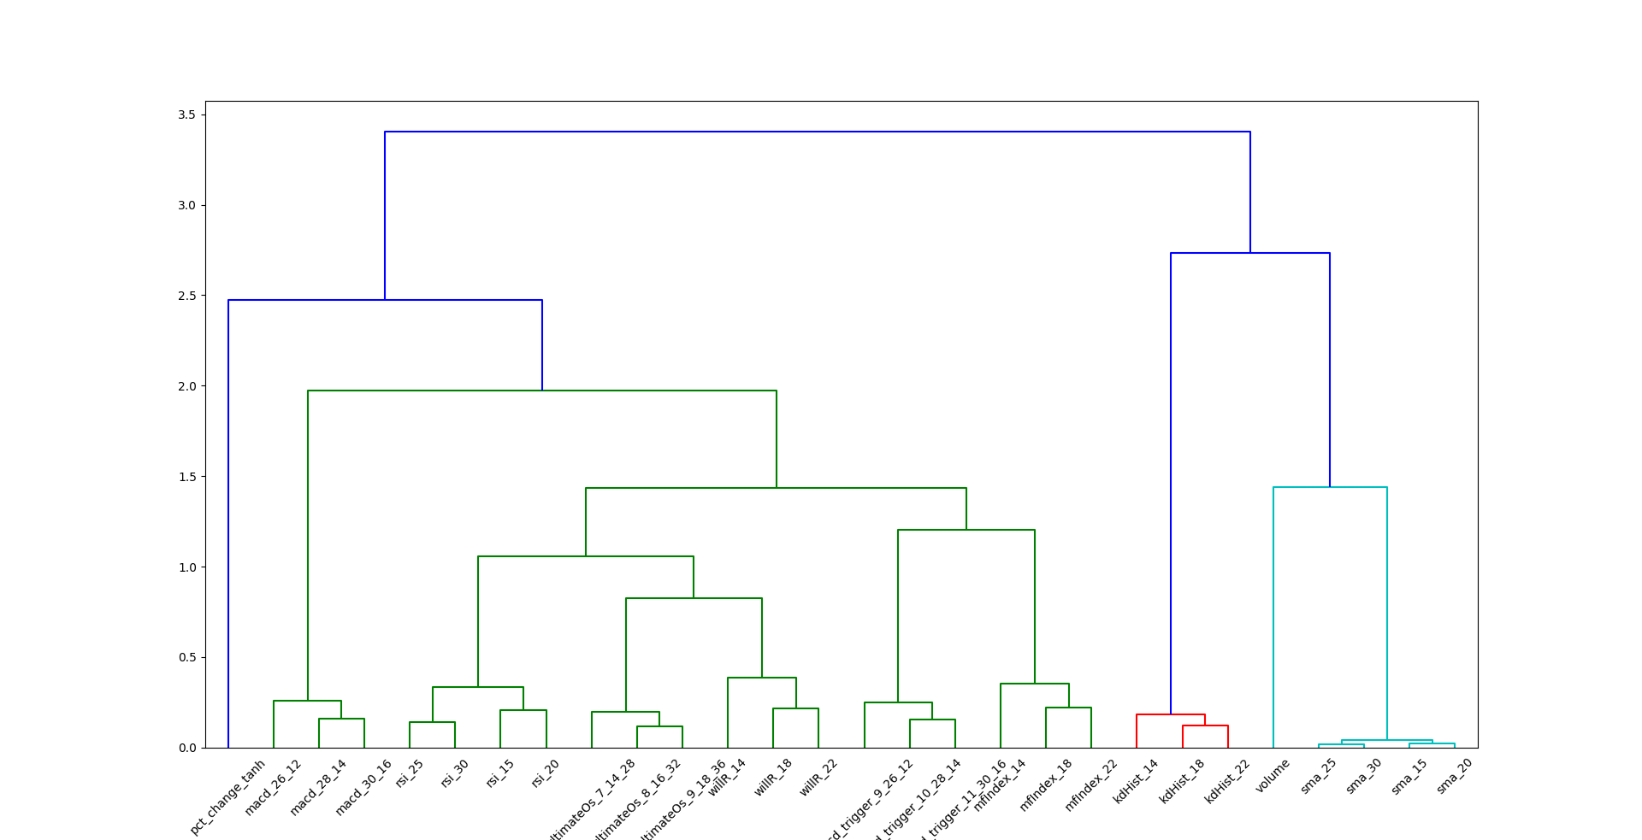

D. Images
As stated before, CNN takes input as images and update weight of filters which convolves over images. Hence, we need images to feed CNN model. Features stated in Table 2. calculates for all training and test data. As a result, every sample day has 28 different features. If we were used multi-layer perceptron to predict trend, these feature works would be sufficient to conduct an experiment. However, CNN takes 2D input which need to be square matrix. Hence, we perform sliding window approach to split this 28-line time series into 28x28 chunks. Sliding window is slid one day at a time. Each square matrix is labeled with following day of last day used in creation of matrix. Following day is selected because we want to forecast trend for the day after of any given day. As a feature size and split size, 28 has different meaning. It consists of 4 weeks exactly. Therefore, patterns arise from exchanges which are performed period of week or month will be more detectable for CNN model.

4. Results
- -Confusion matrix

